

# 清华大学国际学生校内公寓预订说明

**重要提示：凡经预订系统订房成功的学生，可在校内国际学生公寓住宿一年（学习时间不足一年者以录取通知书上写明的学习时间为准）。研究生最晚需在2019年7月11日前退房，专业进修生及汉语进修生最晚需在2019年7月4日前退房，退房之后请自行安排校外住宿。**

1. 预订系统地址为：<http://reser.myhome.tsinghua.edu.cn/>
2. 预订时间为（北京时间，GMT+0800）：

2018级研究生、2018级非学位生：2018年9月17日8: 30 — 2018年9月18日8: 00

房源有限，先到先得，订完为止。

1. 预订时使用本人学号和出生日期登录。学号见《录取通知书》左上角（10位），出生日期格式为“年-月-日”，例如1990年7月1日请输入“1990-07-01”。
2. 预订房间须使用银行卡网上支付定金人民币500元，请在预订前准备好已经**开通网上支付功能**的银行卡。系统的中文界面接受中国国内银行发行的银联卡（China UnionPay），英文界面接受Visa或者MasterCard卡。中国国内发行的同时带有银联和VISA或者同时带有银联和MASTER的卡片无法支付。预订前，请务必与发卡行确认所使用的银行卡可以在网上向中国境内系统转账。网上支付须在预订后1个小时内完成，过时预订信息将被取消。

|  |  |
| --- | --- |
| 房型 | 房价 |
| 单人间 | 80元/间/天 |
| AB间 | 80元/间/天 |
| 双人间 | 40元/床位/天 |

1. 成功预订房间并支付定金的学生需在**9月19日至9月25日**期间办理入住手续。未在此期间办理入住手续且未与公寓联系说明情况者，其预定房间将被取消。
2. 办理入住时须一次性交清一学期的房费（从办理入住之日至2019年1月24日）及200元押金，房间价格请见右表。
3. 如遇到任何问题，可以发邮件到[gaopei@tsinghua.edu.cn](mailto:gaopei@tsinghua.edu.cn)咨询，邮件中需注明本人学号和姓名。
4. 未能成功预订到房间的学生，须自行安排校外住宿。

# **Instructions for Tsinghua University International Students Dormitory Room Booking Application System**

# **Warm Reminder:** Only one year on-campus accommodation is guaranteed to students who have booked a room online successfully (The on-campus accommodation for the students whose study period is less than one year is guaranteed during their study period specified on the Admission Notice only if they successfully book the room online). After one year, students should make their own off-campus accommodation arrangements.

**Graduate Students should check out before July 11th, 2019.**

**Visiting Students and Chinese Language Students should check out before July 4th, 2019.**

1. The application system is available on <http://reser.myhome.tsinghua.edu.cn/>.
2. Online application

Date and time (Beijing time, GMT + 0800): 8:30 AM September 17th, 2018 – 8:00 AM September 18th, 2018.

**Only for international graduate students and non-degree program students who enrolled in the fall semester of 2018.**

There are only a limited number of rooms available. ***First come, first served.***

1. Use your student ID number and date of birth to log in. The student ID (10 digits) is printed on the top left of your *Admission Notice*. The birthdate shall be inputed in the format “yyyy-mm-dd” (e.g., use “1990-07-01” to stand for July 1st, 1990.).
2. A deposit of RMB 500 is required for the reservation. Please prepare a bank card ***which supports online payment***. On the English version of the system, Visa card and MasterCard are accepted; on the Chinese version, China UnionPay card (issued by Chinese banks) is accepted. Cards issued by Chinese banks with the signs of UnionPay & Visa or the sign of UnionPay & Master cannot be used. Before booking, we strongly suggest you contact your bank to confirm that the credit card distributor has not blocked the Chinese payment servers, as this issue has occurred to several students before. If you fail to pay within 1 hour after your booking, the reservation will be canceled.
3. Students who have successfully booked a room and paid the deposit should check in from September 19th to September 25th.If you do not check in during this period and do not contact the apartment, the reservation will be cancelled.

|  |  |
| --- | --- |
| **Room Type** | **Room Price** |
| Single Room | RMB 80/room/day |
| AB Room | RMB 80/room/day |
| Double Room | RMB 40/bed/day |

1. You need to pay for the room rental fee for the whole semester (to January 24th, 2019) upon check-in, plus 200 RMB for deposit. The room price is listed in the following table.
2. If you have any questions or problems, please send an email to [gaopei@tsinghua.edu.cn](mailto:gaopei@tsinghua.edu.cn). Remember to clearly specify your student ID number and your name to make it easier for the staff member to help you.
3. The students who fail to book the rooms need to arrange off-campus housing by themselves.

登陆系统

Log in

查看房间信息

Read room information

预定房间

Book a room

支付定金

Pay the deposit

有房间

If room is available

查看预定结果

Check the booking result

预定完成

Booking complete

1. **登录系统 Logging in ：**

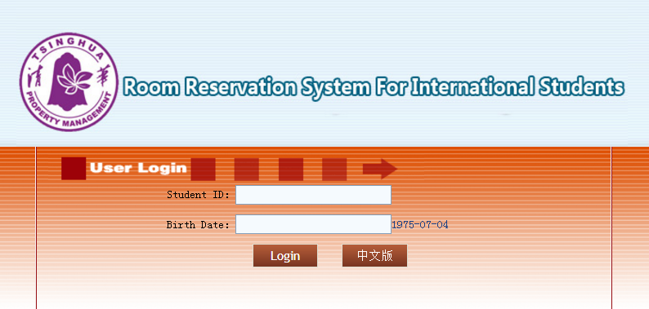

输入学号与生日

Login with your student ID and date of birth

**二、查看房间信息 Read Room Information：**

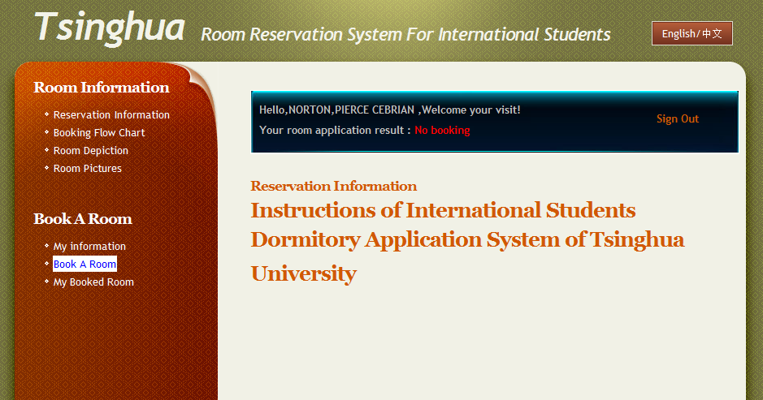

查看订房须知

Information on how to reserve a room

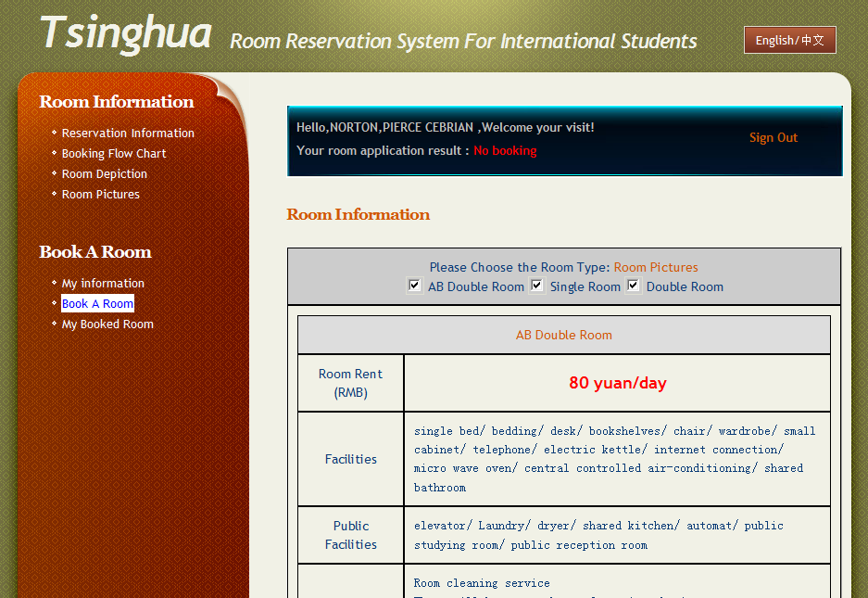

查看房间介绍

Introduction to the rooms

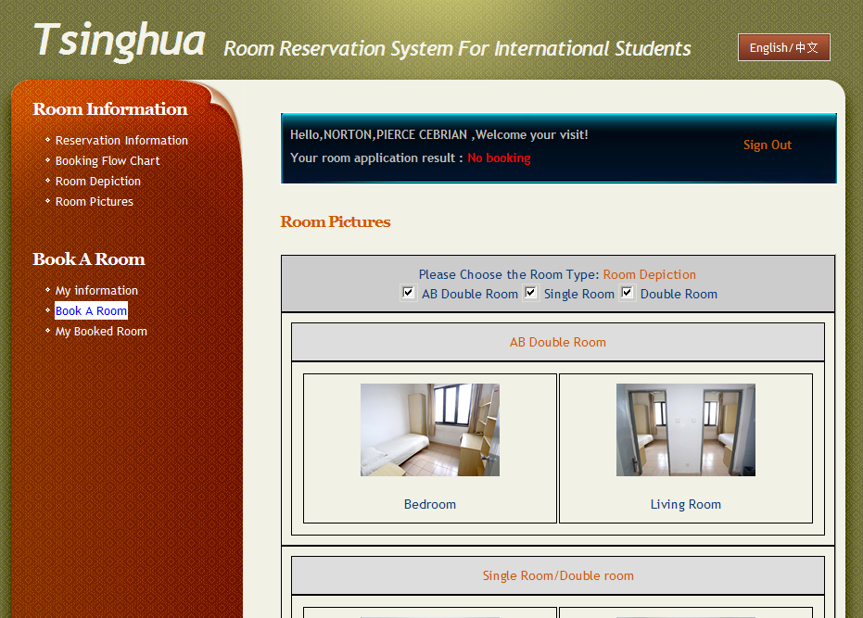

查看房间图片

Room pictures

**三、预订房间 Booking a Room:**

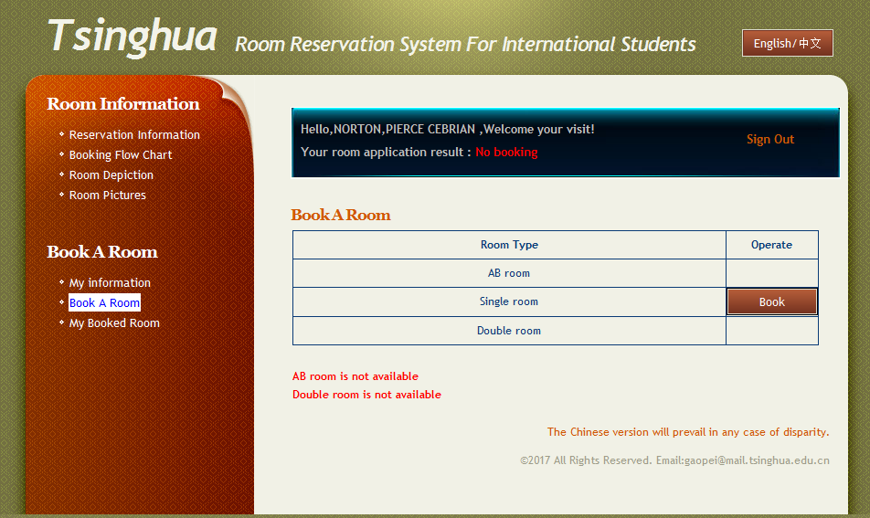

预订房间

Booking a room

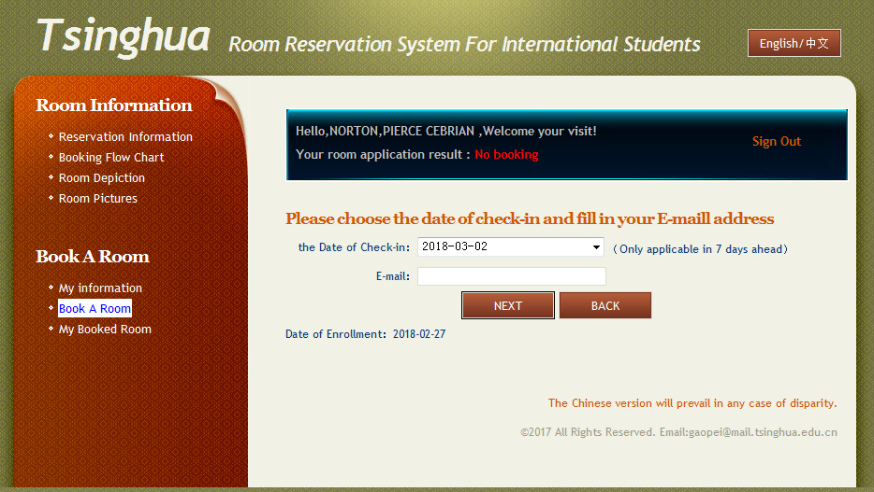

填写入住时间和邮箱地址;

Fill in your date of check-in and E-mail address

**四、支付定金 Pay the Deposit:**

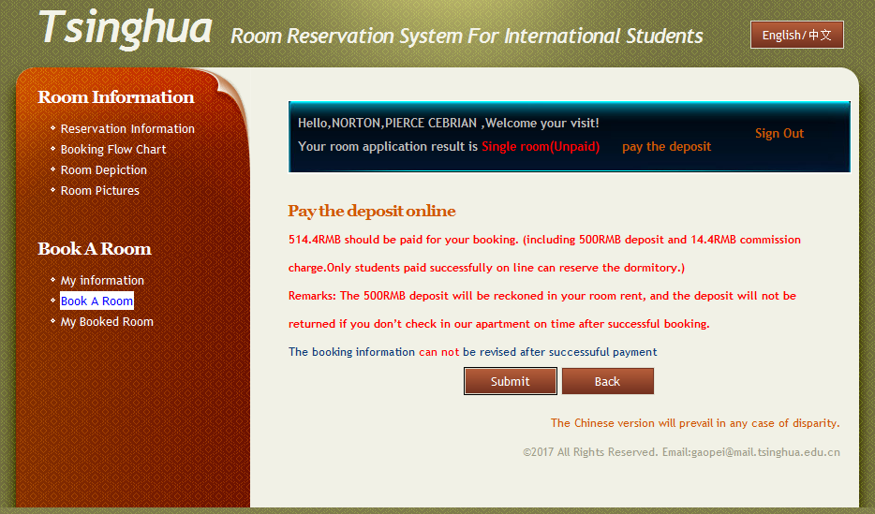

支付定金 Information on deposit payment

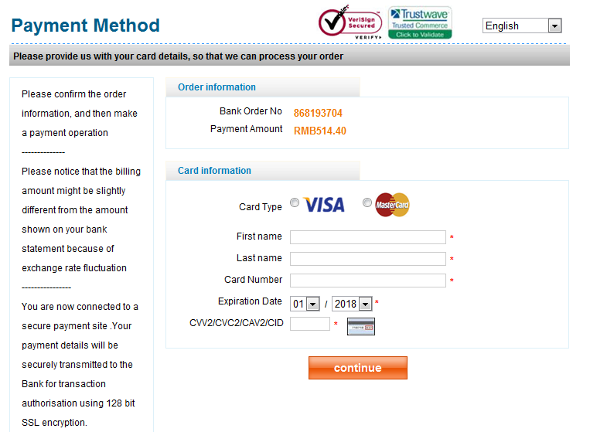

使用银行卡进行支付 Paying with bank card

pay the deposit

**五、查看预订结果 Checking the booking result：**

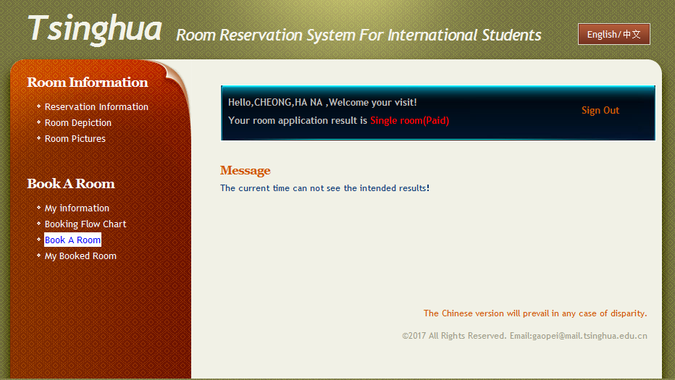

查看预订结果

Check the booking result